**Assignment 2**

**Name:** Sahil Kaundal **UID:** 21BCS8197

**Sem.:** 4th **Section/Group:** 807/B

**Subject:** Principles of AI **Subject Code:** 20CST-258

**Q1.**

**How semantic networks can be used for knowledge representation.**

**Answer.**

A semantic network is **a graphic notation for representing knowledge in patterns of interconnected nodes**. Semantic networks became popular in artificial intelligence and natural language processing only because it represents knowledge or supports reasoning.

 Semantic networks are alternative of predicate logic for knowledge representation. In Semantic networks, we can represent our knowledge in the form of graphical networks. This network consists of nodes representing objects and arcs which describe the relationship between those objects. Semantic networks can categorize the object in different forms and can also link those objects.

This representation consist of mainly two types of relations:

* IS-A relation (Inheritance)
* Kind-of-relation

**Example:** Following are some statements which we need to represent in the form of nodes and arcs.

Statements:

1. Jerry is a cat.
2. Jerry is a mammal
3. Jerry is owned by Priya.
4. Jerry is brown colored.
5. All Mammals are animal.

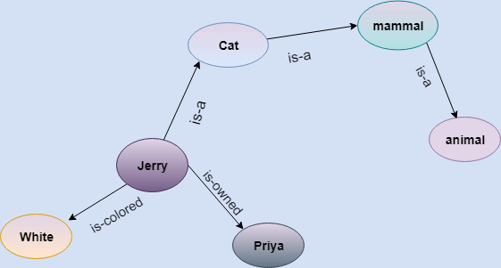

In the above diagram, we have represented the different type of knowledge in the form of nodes and arcs. Each object is connected with another object by some relation.

**Drawbacks in Semantic representation:**

1. Semantic networks take more computational time at runtime as we need to traverse the complete network tree to answer some questions. It might be possible in the worst-case scenario that after traversing the entire tree, we find that the solution does not exist in this network.
2. Semantic networks try to model human-like memory (Which has 1015 neurons and links) to store the information, but in practice, it is not possible to build such a vast semantic network.
3. These types of representations are inadequate as they do not have any equivalent quantifier, e.g., for all, for some, none, etc.
4. Semantic networks do not have any standard definition for the link names.
5. These networks are not intelligent and depend on the creator of the system.

**Advantages of Semantic network:**

1. Semantic networks are a natural representation of knowledge.
2. Semantic networks convey meaning in a transparent manner.
3. These networks are simple and easily understandable.

**Q2.**

**Explain property inheritance algorithm with example.**

**Answer.**

Knowledge of real-worlds plays a vital role in intelligence and same for creating artificial intelligence. Knowledge plays an important role in demonstrating intelligent behavior in AI agents. An agent is only able to accurately act on some input when he has some knowledge or experience about that input.

The algorithm for single inheritance, where every concept has at most one abstraction, is simple:

* First see if the concept explicitly specifies a value for that attribute. If so, return it.
* Otherwise, if the concept has no abstraction, then return failure.
* Otherwise, repeat with concept equal to the abstraction.

For example, consider the following hierarchy:

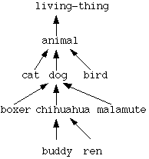

**Inheritable knowledge:**

Relational knowledge is made up of objects consisting of

* attributes
* corresponding associated values.

We extend the base more by allowing inference mechanisms:

* + Property inheritance

a. elements inherit values from being members of a class.

b. data must be organised into a hierarchy of classes.

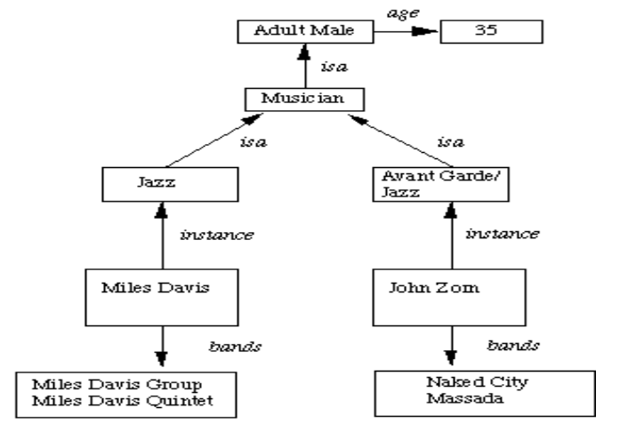

* Boxed nodes -- objects and values of attributes of objects
* Values can be objects with attributes and so on.
* Arrows -- point from object to its value.
* This structure is known as a slot and filler structure, semantic network or a collection of frames.

**The algorithm to retrieve a value for an attribute of an instance object:**

* Find the object in the knowledge base
* If there is a value for the attribute report it
* Otherwise look for a value of instance if none fail
* Otherwise go to that node and find a value for the attribute and then report it
* Otherwise search through using isa until a value is found for the attribute.